KnowledgeQ - Empowering Minds, Anytime, Anywhere.

# Description:

KnowledgeQ Interactive Consultancy Services Private Limited, based in Coimbatore, India, is a versatile technology and software solutions provider. Established in 2007, KnowledgeQ has consistently delivered innovative and high-quality solutions across diverse fields including E-learning, Media Design, Software Development, Quality Assurance & Testing, Artificial Intelligence, IoT & Embedded Systems, Web Hosting. With over 17 years of expertise, our client-focused approach and adoption of advanced technologies allow us to continually surpass client expectations.

**Website:** https://knowledgeq.com/

# 1. Objective:

To build a centralized platform for managing service domains, client engagements, projects, internal team collaboration, and innovation initiatives. The portal will also serve as a resource hub for employees and a reporting tool for management.

# 2. Roles:

1. Admin – Superuser with access to manage users, domains, projects, and analytics.

2. Employee/User – Can view, manage, or contribute to assigned projects, request resources, and update progress.

3. Client (Optional) – Can view their projects' progress, raise tickets, and collaborate on deliverables.

# 3. List of Pages:

## 3.1 Common Pages:

Home Page: A responsive landing page for visitors with company overview, service highlights, contact info, and login redirect.

## 3.2 Admin Pages:

* Login Page: Email and OTP-based authentication system.
* Dashboard: Overview of company KPIs including Active Projects, Employee Count, Client Count, Service Utilization, and Project Status Summary.
* Users Management: List and manage employees, departments, and roles.
* Overview: List of all ongoing and upcoming projects.
* Create/Edit: Admin can initiate new or update details.
* Service Domains: Manage domains like AI, IoT, QA, E-learning etc.
* Reports: Generate reports on Project progress, Resource utilization, Billing & Time Tracking, and Client Feedback.

## 3.3 Employee/User Pages:

* Register/Login
* Dashboard
* My Projects
* Knowledge Base
* Profile Settings

## 3.4 Client Pages (Optional):

* Client Login
* Project Dashboard
* Raise Support Tickets
* Download Deliverables
* Leave Feedback

# 4. Functional Highlights:

* Role-based access control
* Real-time project tracking
* Modular service architecture
* Automated reminders & alerts
* API-ready backend for integration
* Mobile-first responsive UI
* Audit logging for transparency

# 5. Notes & Enhancements (Future Scope):

* Integration with Slack / Microsoft Teams
* Built-in AI Assistant for project analytics
* Support for multi-language interface
* Enhanced Client Communication Module
* Mobile app rollout for employees & clients

# 6. UML Class Diagram:

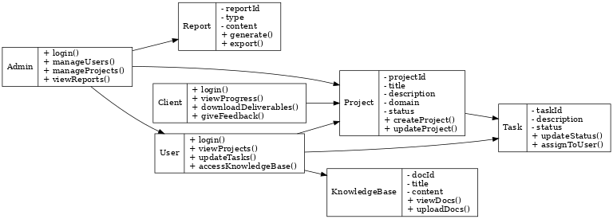

# 7. Technology Stack:

## 7.1 Backend:

* Programming Language: Python
* Database: PostgreSQL
* Authentication: JWT
* API Protocols: RESTful

## 7.2 Frontend:

* Frameworks: React.js
* UI Libraries: Tailwind CSS
* State Management: Redux
* Build Tools: Webpack

## DevOps & Deployment:

* CI/CD: Jenkins, GitHub Actions
* Containerization: Docker, Podman
* Orchestration: Kubernetes, Docker Swarm
* Monitoring: Prometheus
* Logging: ELK Stack
* Cloud Providers: AWS, Azure, GCP

# 8. Conclusion & Value Proposition:

KnowledgeQ stands as a reliable and future-ready technology partner, committed to delivering high-quality, innovative solutions. Our technology stack reflects a strategic blend of stability, scalability, and modernity. Through our integrated platform approach, we empower teams to work efficiently and help clients to achieve their digital transformation goals. Whether it's E-learning, Artificial Intelligence, or Embedded Systems, our comprehensive stack and skilled teams ensure we are equipped to meet any challenge.

This document outlines the core structure, technology foundation, and functional modules that define the operations and offerings of KnowledgeQ. With continuous investments in R&D and a strong customer-centric approach, KnowledgeQ is poised to scale its impact in the tech ecosystem.